Critical values
For confidence intervals and testing hypotheses with acceptance/rejection regions, we need to calculate the critical values Z_{α/2} and t_{α/2} (Z_{α} and t_{α} for one-sided tests).
Use commands
=NORMINV( 1-α, 0, 1 ) to get Z_{α} for the upper-tail probability α
=NORMINV( 1-α/2, 0, 1 ) to get Z_{α/2} for the upper-tail probability α/2
=TINV( α, df ) to get t_{α/2} for the upper-tail probability α/2
(This command gives a two-sided critical value; it will automatically divide α by 2)
=T.INV( α, df ) or =TINV( 2*α, df ) to get t_{α} for the upper-tail probability α
Use the correct number of degrees of freedom df (n-1 for a one-sample test, n1+n2-2 for a two-sample test with equal variances, etc.).

Pvalues
P-value is always the probability to see a test statistic at least as extreme as the one that we have really observed. By “extreme” we mean contradicting the null hypothesis H₀ in favor of the alternative H₁. It is a probability, and to find it, we use the appropriate distribution of the test statistic.
For a Z-test with a test statistic Z_{stat,} use the Standard Normal distribution
=NORMDIST(Z_{stat}, 0, 1, 1) to get the p-value for the left-tail alternative H₁: µ < µ₀
=1-NORMDIST(Z_{stat}, 0, 1, 1) to get the p-value for the right-tail alternative H₁: µ > µ₀
=2*NORMDIST(-abs(Z_{stat}), 0, 1, 1) to get the p-value for the two-sided alternative H₁: µ ≠ µ₀
To get the right-tail p-value, we used the complement, because the NORMDIST command always gives the left-tail probability. For the two-sided test, just take the smaller tail probability and double it. If Z_{stat} is negative, you can use =2*NORMDIST(Z_{stat}, 0, 1, 1). If Z_{stat} is positive, use =2*NORMDIST(-Z_{stat}, 0, 1, 1). I wrote the absolute value “abs” to cover both cases in one command.
For a t-test with a test statistic t_{stat,} use the Student’s t-distribution with the correct degrees of freedom. The command is =TDIST(t_{stat}, df, tails), where tails=1 for a one-sided test and tails=2 for a two-sided test. This command can only handle t_{stat} > 0, and it returns the upper-tail probability. Therefore:
For the right-tail alternative H₁: µ > µ₀, use
=TDIST(t_{stat}, df, 1) to get the p-value, when t_{stat} > 0 (in this case, p-value < 0.5)
=1-TDIST(-t_{stat}, df, 1) to get the p-value, when t_{stat} < 0 (p-value > 0.5, H₀ is accepted)
For the left-tail alternative H₁: µ < µ₀, use
=1-TDIST(t_{stat}, df, 1) to get the p-value, when t_{stat} > 0 (p-value > 0.5, H₀ is accepted)
=TDIST(-t_{stat}, df, 1) to get the p-value, when t_{stat} < 0 (p-value < 0.5)
For the two-sided alternative H₁: µ ≠ µ₀, use
=TDIST(t_{stat}, df, 2) to get the p-value, when t_{stat} > 0
=TDIST(-t_{stat}, df, 2) to get the p-value, when t_{stat} < 0

To summarize, the command =TDIST allows only positive values of t_{stat}. If your t_{stat} is negative, use (-t_{stat}) instead. Also, notice that the p-value > 0.5 when the left-tail test H₁: µ < µ₀ has t_{stat} > 0, and when the right-tail test H₁: µ > µ₀ has t_{stat} < 0. In both of these cases, there is absolutely no support of the alternative, so the p-value is high, and the null hypothesis H₀ is not rejected.

The Data: sample mean, standard deviation, etc.
To get the sample statistics required for tests and confidence intervals, you can refer to one of our past Excel handouts - Descriptive Statistics. Here are the relevant Excel commands
Statistic | Excel function
Sample mean | =AVERAGE(A2:A55)
Sample standard deviation s | =STDEV(A2:A55)
Sample size n | =COUNT(A2:A55)

You can get all of these (and more!) from the Descriptive Statistics tool of the Data Analysis Toolpak:
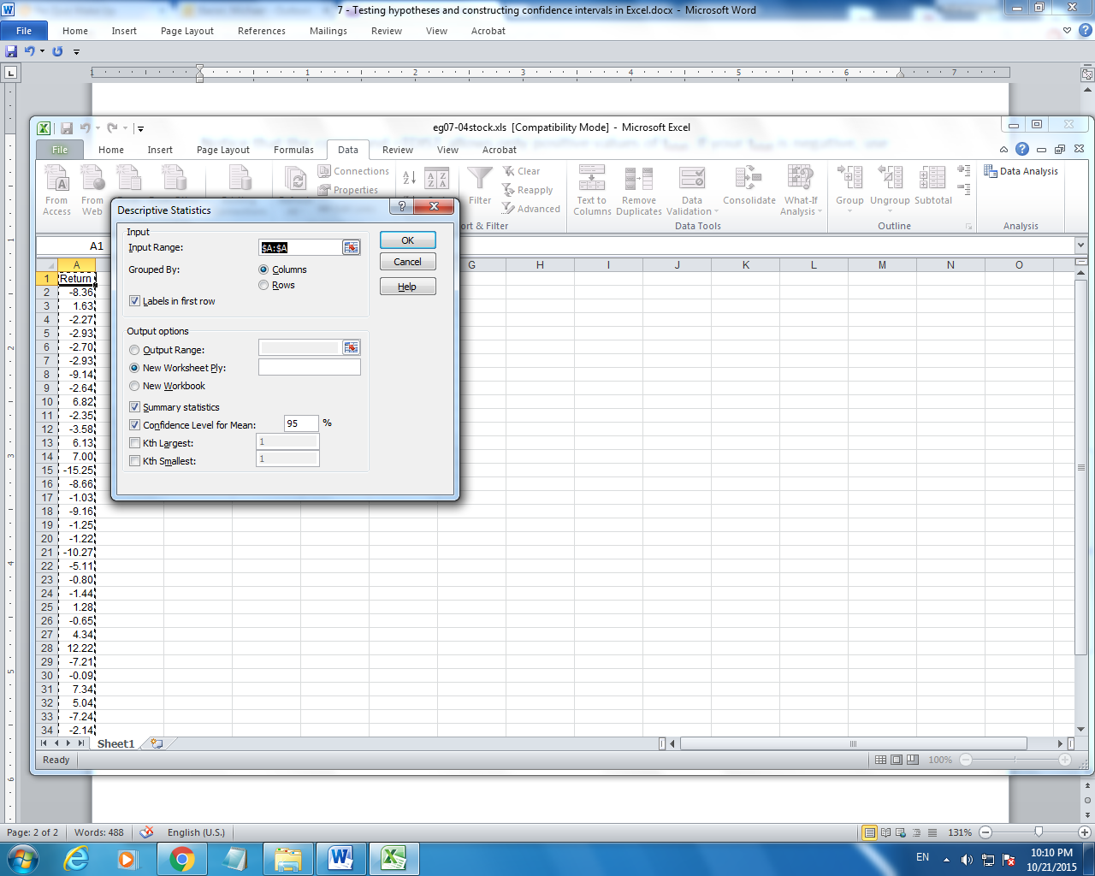
Notice the new box “Confidence level” that I checked…

As a result, we get the sample mean = -1.1, the sample standard deviation s=5.991, and the sample size n=39. Also, there are some shortcuts:
Standard Error 0.959 is in fact Std() = s / √n
Confidence Level (95.0%) is (t_{α/2} s / √n), the margin of the 95% confidence interval for µ. Need a 99% or a 88% confidence interval? Enter that confidence level in the descriptive statistics toolbox instead of 95%.
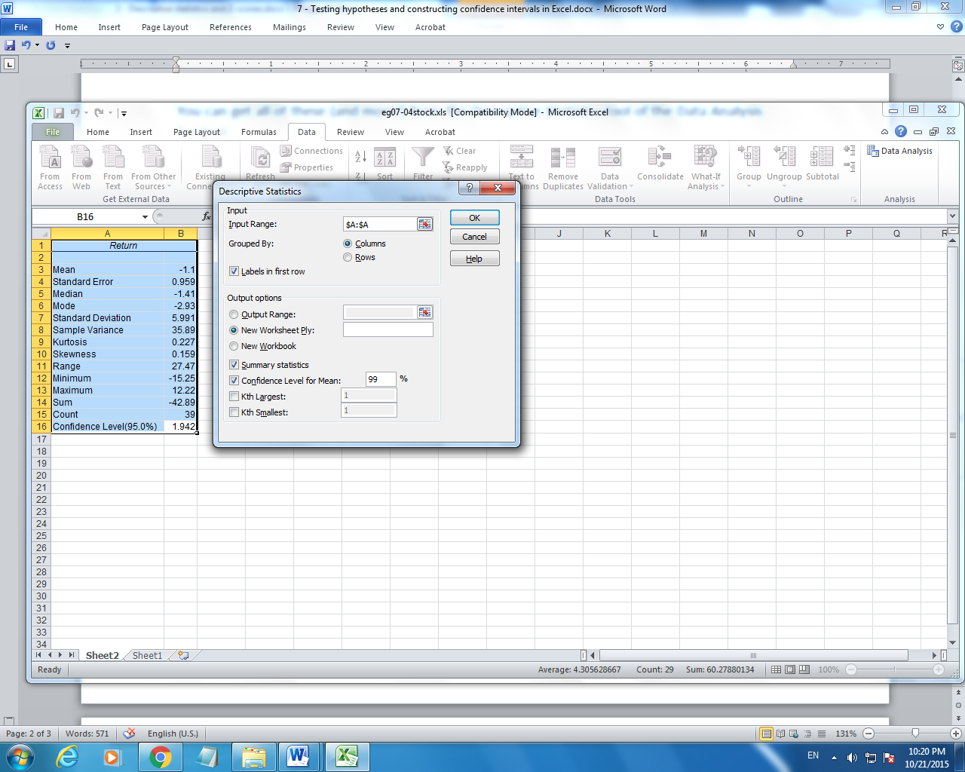

Two-sample procedures in the Data Analysis Toolpak
All of the above can be applied to two-sample tests and confidence intervals for (µ₁ - µ₂).
Also, the Data Analysis Toolpak has procedures for two-sample Z-tests, t-tests, and F-tests. Separate tools are for the case of equal variances and unequal variances.
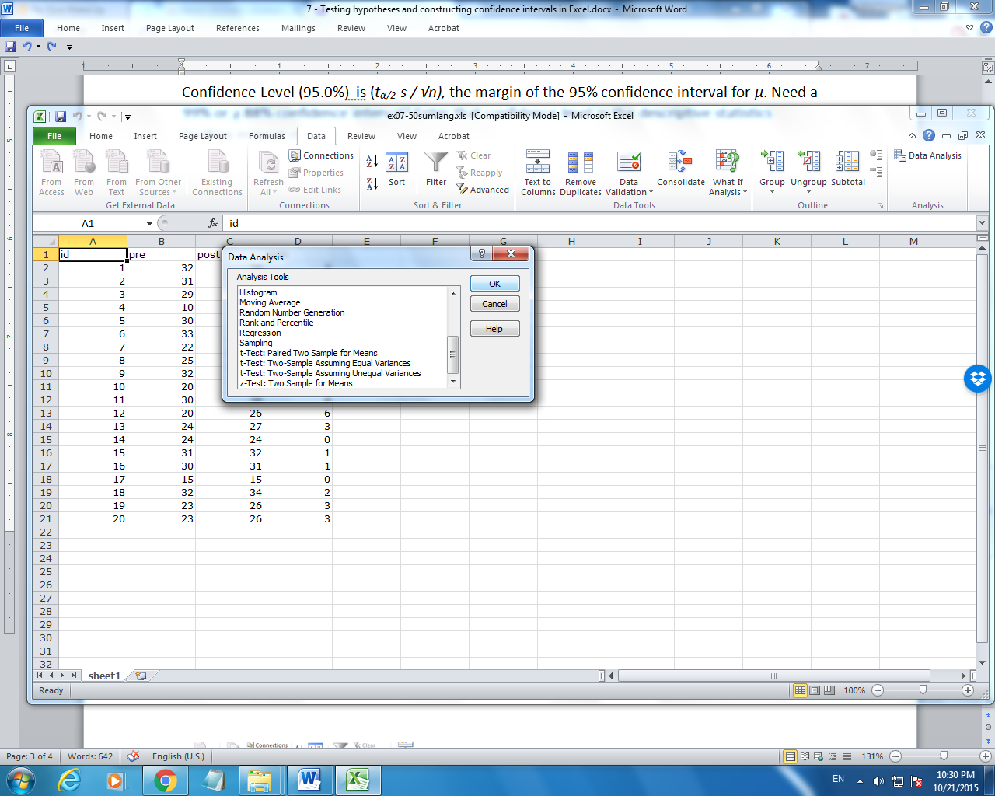
These tests will give you an output similar to this.
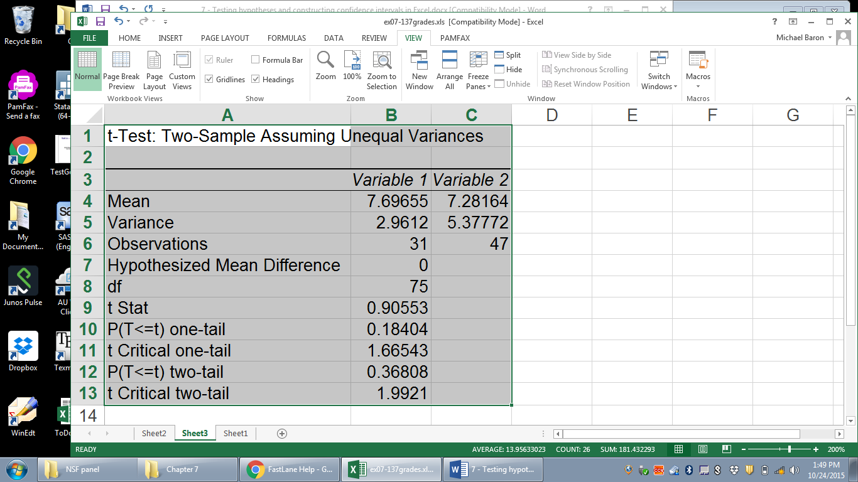
P-values are denoted by P(T<=t). As we know, the two-sided P-value is simply twice the one-sided P-value. Also, there are critical values from the t-table, t_{α} = 1.66543 and t_{α/2} = 1.99210, computed for the level α specified as “alpha” in the toolbox.
This is the unequal-variance t-test, and its df are computed by the Satterthwaite approximation. For the equal-variance test, df = n1+n2-2, and also, the pooled variance will be computed.

F-test comparing two variances
We can use the F-test to decide if the assumption of equal variances is reasonable. It is used to test H₀: σ ₁ = σ ₂ vs H₁: σ ₁ ≠ σ ₂
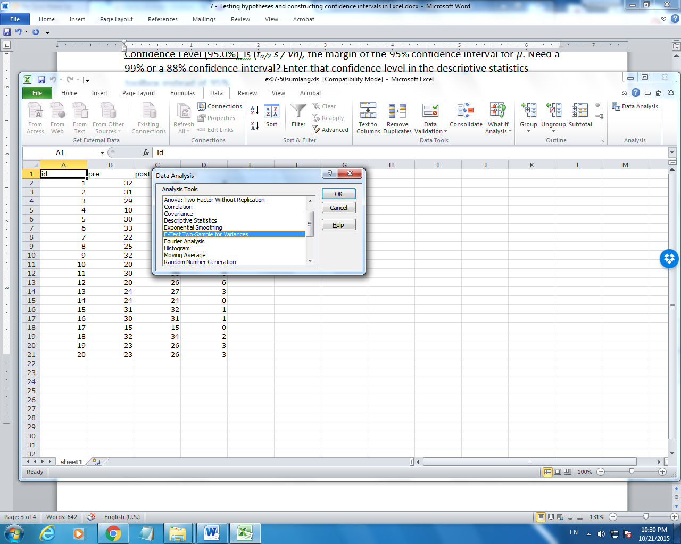

Result of the F-test looks like this.
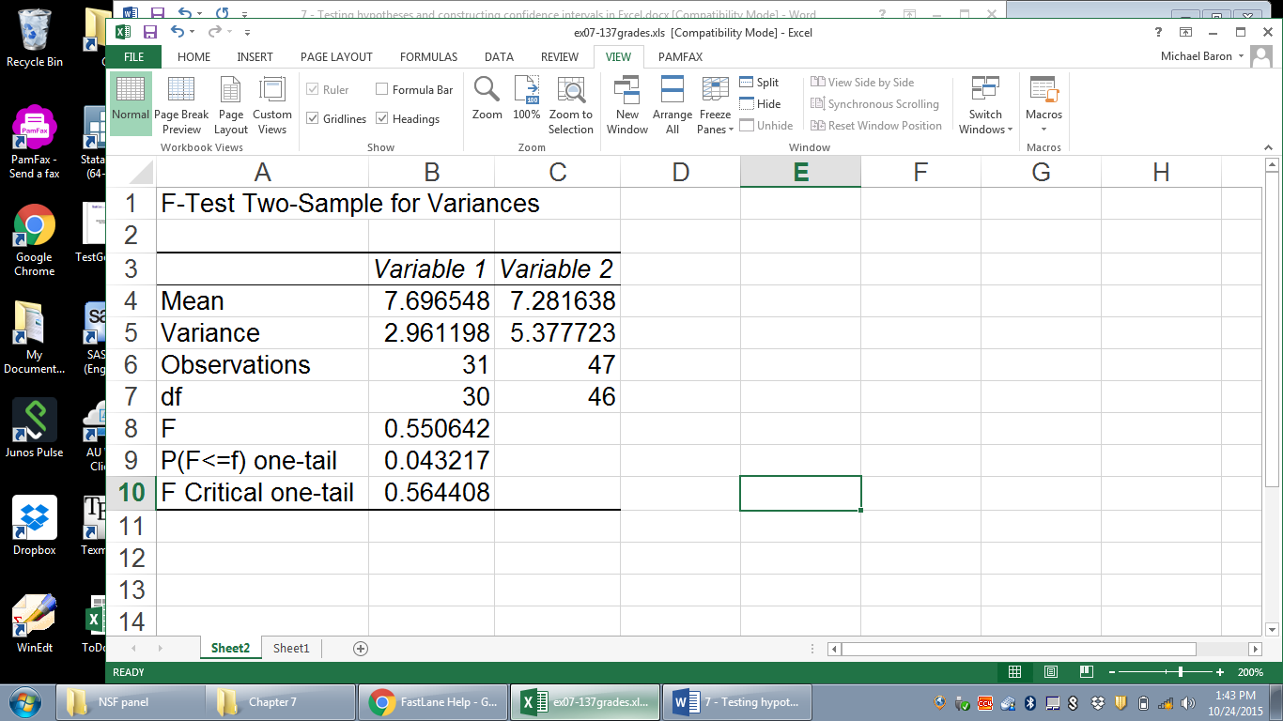
Here, the test statistic F=0.564408 and the one-sided Pvalue = P(F ≤ 0.564408) = 0.043217. You can also obtain this P-value by the command =1-Fdist(0.564408,30,46). Notice, however, that for testing H₀: σ ₁ = σ ₂ vs H₁: σ ₁ ≠ σ ₂ , a two-sided test, the P-value is 2*0.043217 = 0.086434.

